

Faculty of Computers and Artificial Intelligence
Computer Science Department
2021/2022

CS 395 Selected Topics in CS-1
Research Project
Report Submitted for Fulfillment of the Requirements and ILO’s for Selected Topics in CS-1 course for Fall 2021

Team No. 24

 | ID | Name | Grade

Delivered to:
Dr. Wessam El-Behaidy
Eng. Islam Gamal
Eng. Muhammed Kamal

I. NUMERICAL DATASET
1. Project Introduction
  - Dataset Name
Heart Failure Prediction
This data_set used to predict if person will suffer from a heart disease or not.
According to 11 attributes : her/his(1-age , 2- gender , 3- chest pain type , 4-resting blood pressure , 5-serum cholesterol , 6-fasting blood sugar , 7-resting electrocardiogram results , 8-maximum heart rate achieved , 9-exercise induced angina , 10-oldpeak , 11-the slope of the peak exercise ST segment).
And the target is (yes he/she will suffer from heart disease or not) {it is a classification supervised problem}.

  - Number of classes and their labels
There are 2 classes (binary class).
Label (0) mean that ‘no heart disease’.
Label(1) mean that ‘there is a heart disease’.

  - Dataset Samples Numbers
918 rows * 12 coloumns

  - Training, Validation and Testing
20% from data

- Implementation Details
    - Extracted Features
Features=11
Their names :-
(1-age , 2- gender , 3- chest pain type , 4-resting blood pressure , 5-serum cholesterol , 6-fasting blood sugar , 7-resting electrocardiogram results , 8-maximum heart rate achieved , 9-exercise induced angina , 10-oldpeak , 11-the slope of the peak exercise ST segment).
Dimensions are :- (11*918)
After preprocessing :-
The feature(chest pain type)has been categorized into 4 types,
So features became 14 and the dimensions are (14 * 918)

    - Cross-validation
(Is cross-validation is used in any of implemented models? If yes, specify the number of fold and ratio of training/validation)

    - Artificial Neural Network (ANN)
- Hyper-parameters

Optimizer,regularization = ‘adam’,
batch_size = 100 ,
epochs = 30

    - Support Vector Machine (SVM)

opt = tf.keras.optimizers.SGD(learning_rate=learning_rate)
Optimizer = opt
Epochs = 400
Batch_size = 100

- Hyper-parameters
(Specify all the hyper-parameters (optimizer, regularization, …) with their specified value in implementation)

- Models Results
For each model you should show all these results for your model on testing data (loss curve, accuracy, confusion matrix, ROC curve)

  - ANN Results
Loss curve:-
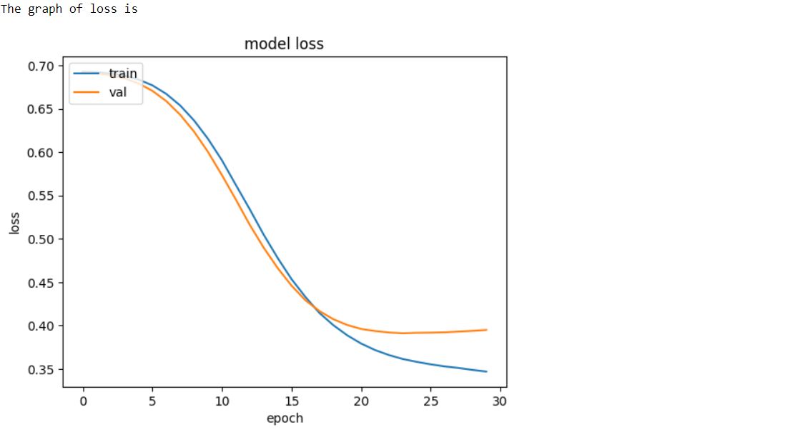
Accuracy:-
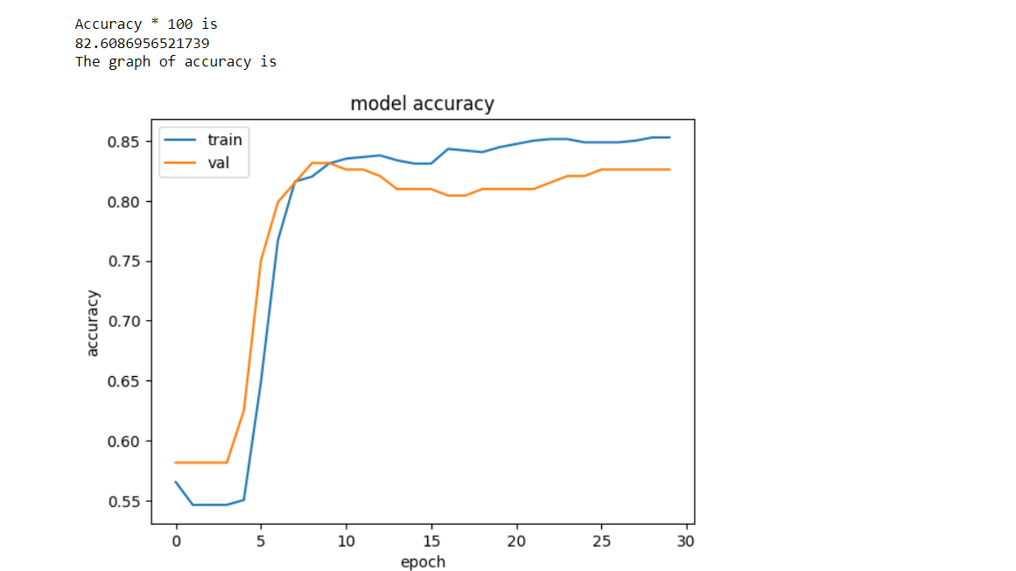

Confusion matrix:-
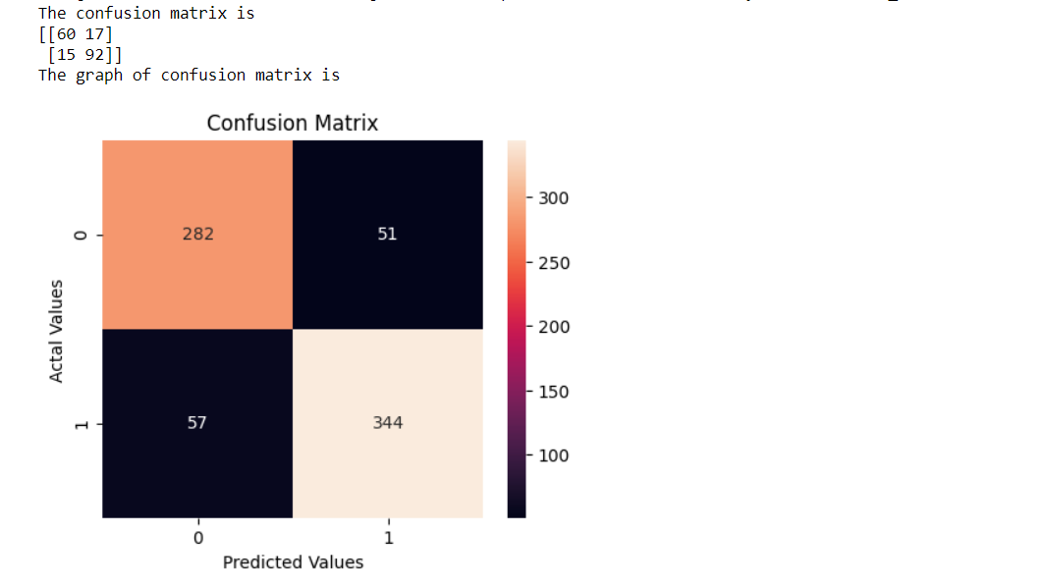

ROC curve:-
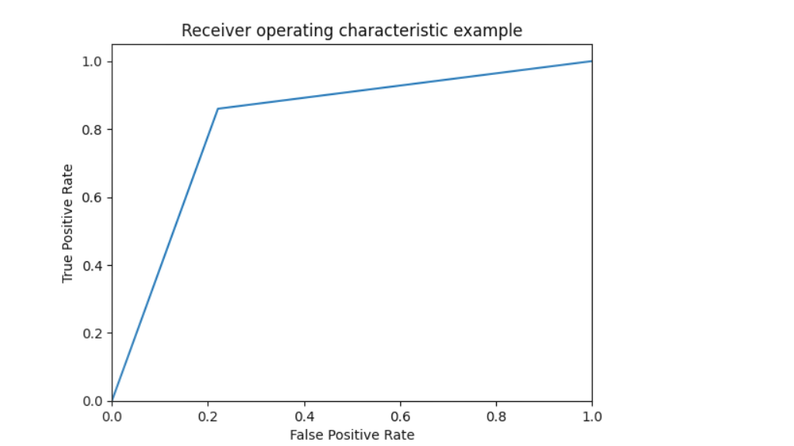
  - SVM Results
Loss curve:-
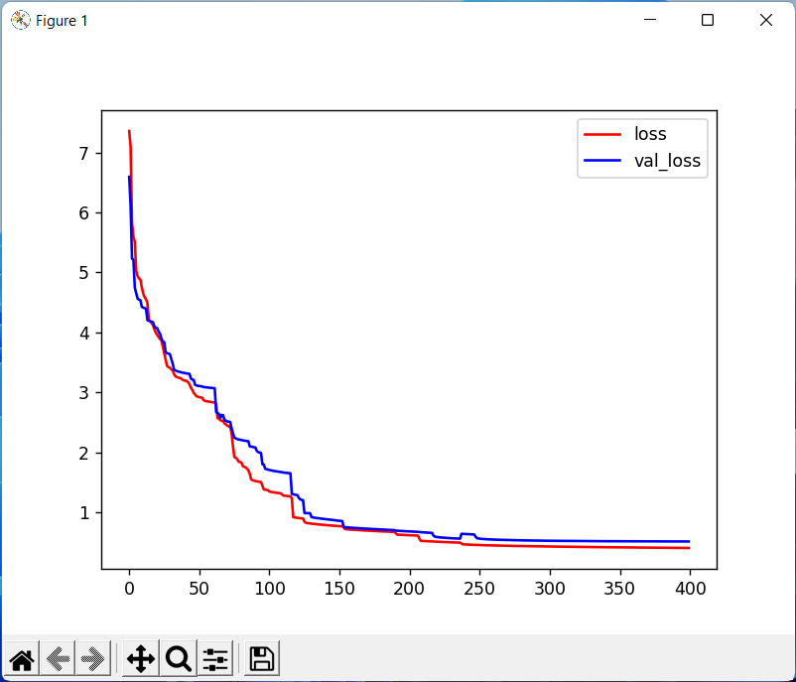
Accuracy:-
The accuracy * 100 =
86.10354223433242

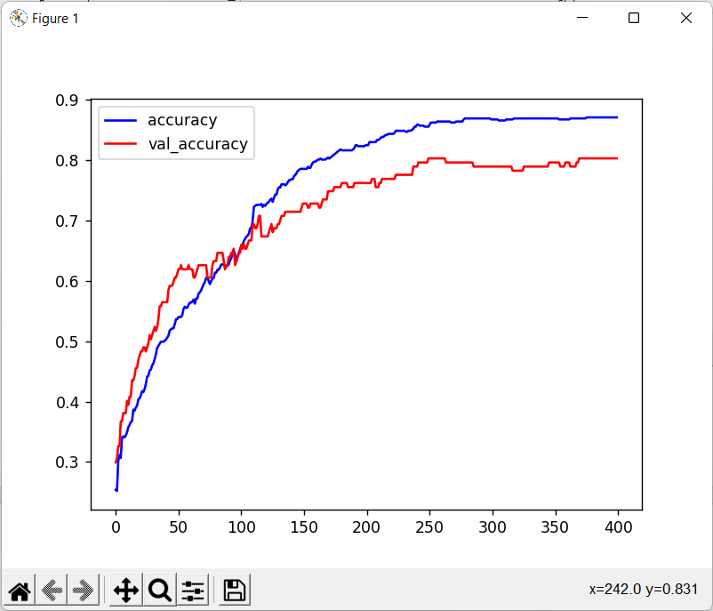

Confusion matrix:-
Confusion Matrix is:
[[35 6]
[ 6 45]]

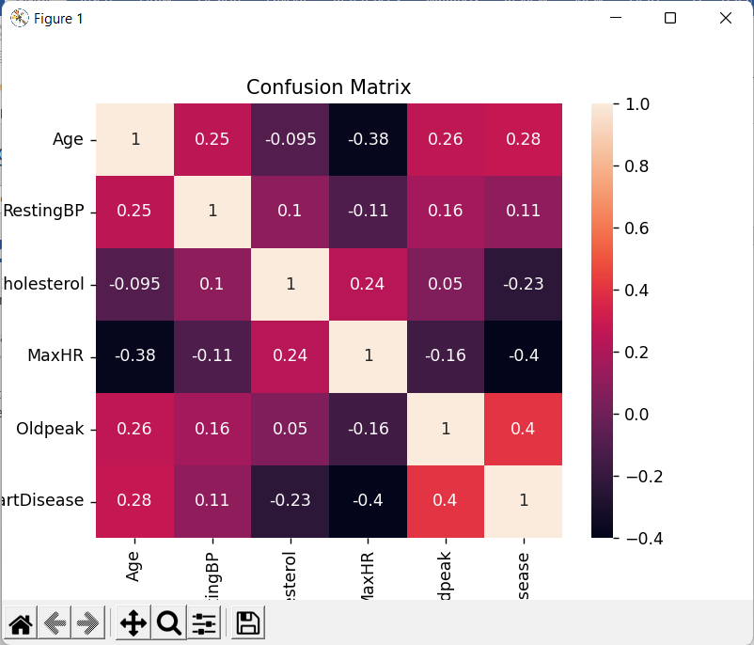

ROC curve:-
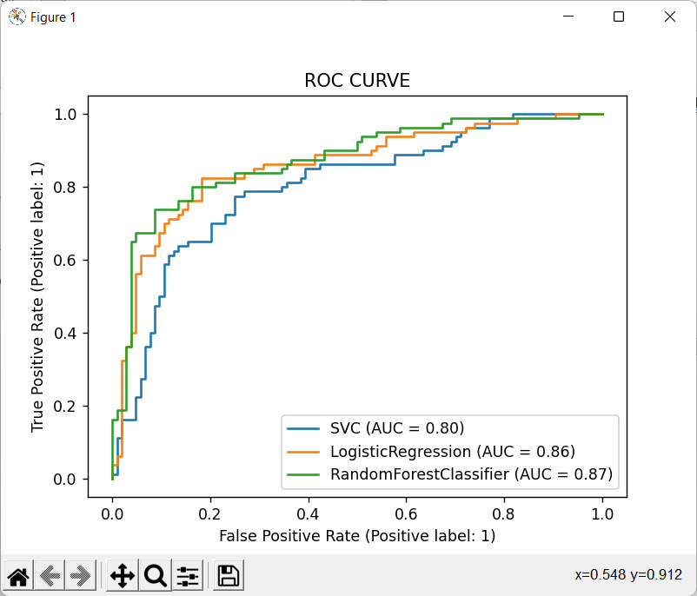

II. IMAGE DATASET
1. Project Introduction
  - Dataset Name
(What is the dataset used?)

  - Number of classes and their labels
(Specify number of classes and their labels.)

  - Dataset Images Numbers and size
(The total number of images in dataset and the size of each.)

  - Training, Validation and Testing
(The number of images used in training, validation and testing.)

2. Implementation Details
    - Extracted Features
(How many features were extracted, their names, the dimension of resulted features)

    - Cross-validation
(Is cross-validation is used in any of implemented models? If yes, specify the number of fold and ratio of training/validation)

    - Artificial Neural Network (ANN)
- Hyper-parameters
(Specify all the hyper-parameters (initial learning rate, optimizer, regularization, batch size, no. of epochs…) with their specified value in implementation)

    - Support Vector Machine (SVM)
- Hyper-parameters
(Specify all the hyper-parameters (optimizer, regularization, …) with their specified value in implementation)

3. Models Results
For each model you should show all these results for your model on testing data (loss curve, accuracy, confusion matrix, ROC curve)

  - ANN Results

  - SVM Results

